Roy Welborn

1.4 Professional Presentation Analysis: Assignment

Video presentation review for:

<https://www.ted.com/talks/torsten_reil_studies_biology_to_make_animation>

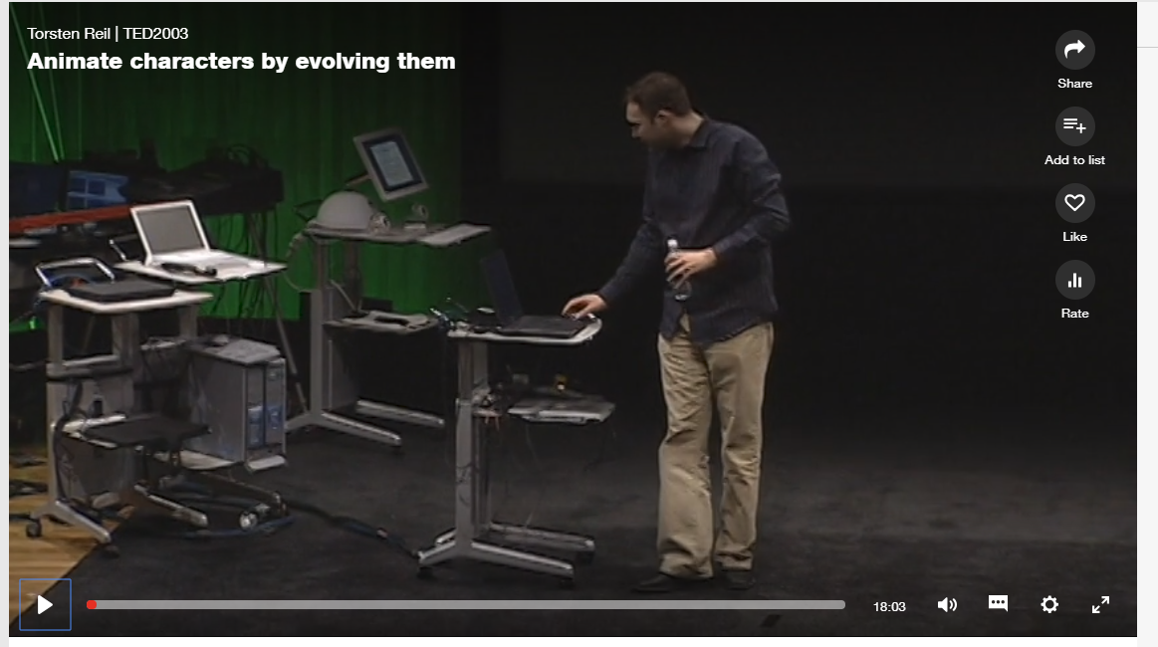

In this presentation, Torsten Reil, demonstrates how artificial intelligence could be used in game and movie characters with a more realistic approach.

This presentation is of particular interest to me, being an avid online gamer. The current NPC (non player character) is very stale and not very immersive. With this new technology games, and even movies that use quite a bit of CGI will be more realistic, immersive, and more engaging to the end user.

The presentation was made more relatable by the content in which Mr. Reil related on how they build on past mistakes to where they had a working example of how artificial intelligence can be used, and how they ‘grew’ the model from not being able to walk to almost a full-fledged human equivalent in the end product of their software.

The end user drew people in further to the presentation by showing them the process, in video, from beginning as the construct could not walk, to where the construct acted via certain stimuli, such as being pushed, explosions in the air, or even being tied.

The presentation was much better than possibly reading a white paper on the subject with the fact you could see the progression of the humanization of the construct rather than just reading text on paper. This venue of showing the ‘growing up’ of the character and its possible uses was very intriguing and the application to the gaming and movie industry was evident by the video presentations.

In my opinion the presenter didn’t use very many emotions for this presentation other than his enthusiasm for the work they were doing, the destiny of this kind of software and the impact it will have on future games, and movies. However, he did move many people with the possibilities of the software being developed, in the ‘make me thing’ ideals presented.

Roy Welborn

1.4 Professional Presentation Analysis: Assignment

Video presentation review for:

<https://www.ted.com/talks/meron_gribetz_a_glimpse_of_the_future_through_an_augmented_reality_headset>

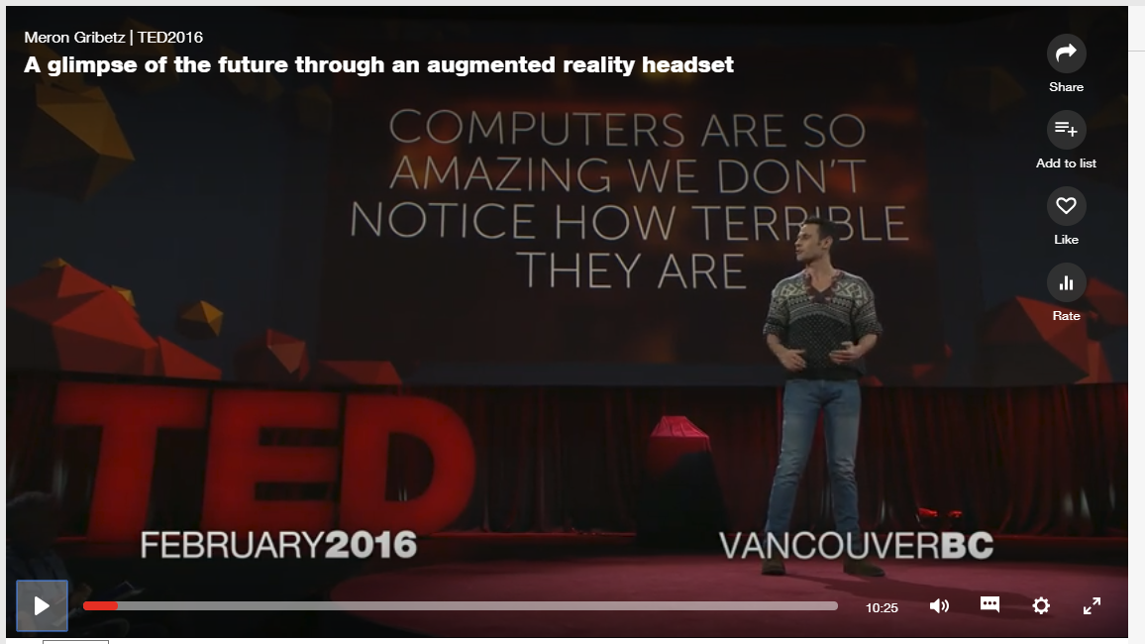

In this presentation, Mr. Gribetz from the Meta Company showcases their augmented reality, and the future of the augmented reality.

The presenter in this video uses his enthusiasm for augmented reality and his history of neuroscience to engage the audience about living in a three dimensional world instead of a boring two dimensions we currently live in. Using the fact the people are social creatures and crave social interaction that we have lost by just looking at our phones, and computer monitors. With augmented reality you can still socialize, share, and interact with your peers, and friends to have a more fulfilling existence, rather than just focus on inanimate objects of the two dimensional realm.

The presenter touch on several aspects during the videos, such as he made people think about their everyday life in two dimension world, made them sympathize about their existence of non-social interaction, and made them very intrigued by the possibilities of augmented reality, in every aspect of daily life.

He continues to draw the audience to think for themselves what realms they could use this technology for phones, and transferring items between friends, family and coworkers.

Roy Welborn

1.4 Professional Presentation Analysis: Assignment

Video presentation review for:

<https://www.ted.com/talks/alex_kipman_the_dawn_of_the_age_of_holograms>

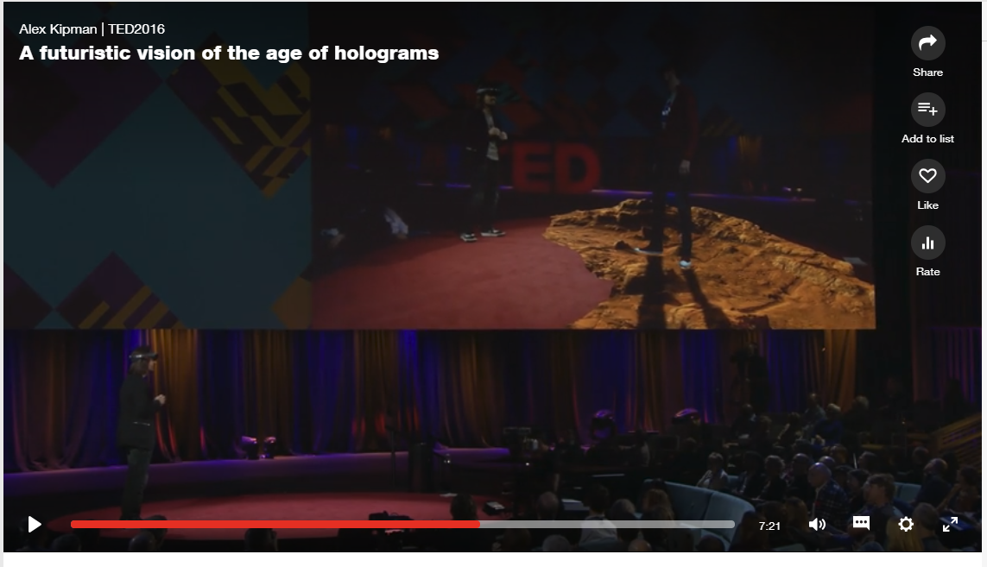

This presenter was by far my favorite, he was engaging, thought provoking, and very good at working the audience in his presentation.

Mr. Kipman kept using the word, ‘imagine’, this drew in the audience to think about the possibilities with their life, their interactions, and what could be, in the future with their own imagination.

The presenter was extremely positive and enthusiastic with his presentation and the audience could not help being drawn in, and feel exactly what the presenter was feeling, and the emotion that was presented was as uplifting as if you had the hololens on your head watching as he was showing you in the auxiliary camera.

At the end of the presentation you could not help dreaming along with the presenter about possibilities, and the feeling this could be a great thing for the future of people who are stuck in a two dimensional world to finally come out of that lonely existence and be social, and comforting in the fact you are back in the embrace of people once more.